c4 questions we ask for EVERY keyword
From now on, whenever you see a keyword, ask:

Question 1
Is it relevant to my business?
Yes / No

Question 2
What does the searcher want?
Informational / Commercial / Transactional / Local

Question 3
How much search demand does it have?
Use Keyword Planner.

Question 4
Could this searcher become my customer?
High / Medium / Low
That's the core of keyword analysis.

Keyword Analysis (Short Summary)
- Keyword: What people search on Google.
- Keyword Research: Finding and analyzing those searches.
- Seed Keyword: Starting keyword, e.g. electrical shop.
- Search Intent: Informational, Commercial, Transactional, Local.
- Search Volume: Approximate number of searches.
- Competition: Mainly Google Ads competition in Keyword Planner.
- Relevance: Is the keyword related to our business?
- Business Value: Can it bring potential customers?
- Primary Keyword: Main keyword/topic of a page.
- Secondary Keywords: Related supporting keywords.
- Keyword Mapping: Assigning keywords to the correct website pages.
- Keyword Placement: Title, H1, content, meta description, etc., naturally.
- Main rule: Relevance + Intent + Business Value > just high search volume.
Process:
Find → Analyze → Filter → Group → Primary/Secondary → Map to Pages

Lesson – 3 : Competitor Analysis , Title & Meta Description Creation
Competitor analysis : means studying businesses that compete with you to understand what they are doing online.
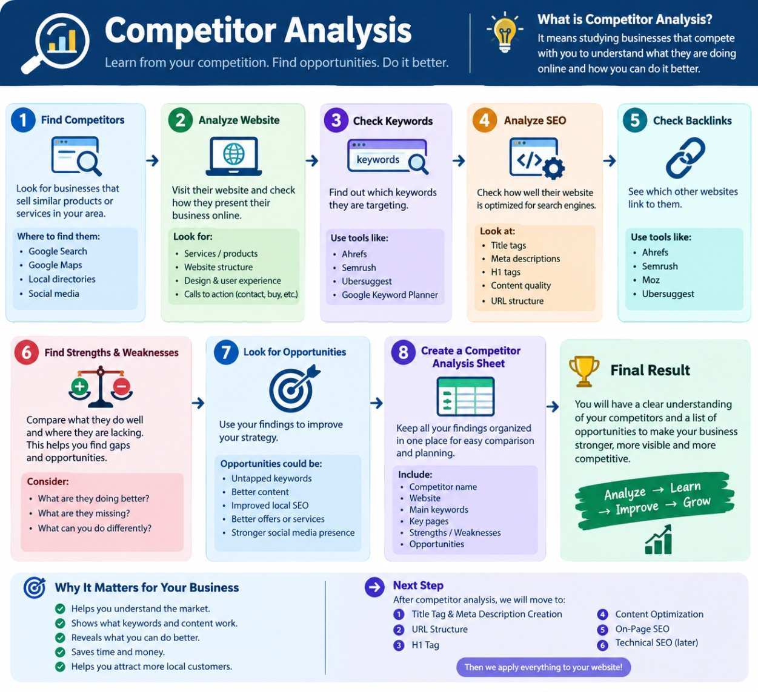

Back link : A backlink is when another website links to your website. It brings referral visitors to your page and also acts as a signal of SEO
SEO Title : the title of a webpage that tells Google and users what the page is about.
- 50 – 60 characters ex: Electrical Shop in Hanamkonda | Electrical & Hardware
- primary keyword should usually appear in the title.
- Put Important Words Near the Beginning ex : Electrical shop in Hnk | ABC Electricals is better than ABC Electricals | Products & services | Electrical shop in hanmakonda
- Make Every Page's Title Different that should reflect the purpose of each page Ex: plumbing , hardware , etc
- Don’t stuff the keywords (keyword stuffing)
- Add business name on important pages like home page
- Make it understandable and readable for users
- Avoid false promises and info about products , costs etc
- Simple way to make a seo title : Primary Topic/Keyword + Location (when relevant) + Business Name

Meta description : a short description that explains what the webpage offers and encourages the user to click.
- 150 – 160 characters
- Keep it relevant to the page
- Include the main topic naturally
- Write for humans, not just Google
- Don't stuff keywords
- Make every page's description different
- Give a reason to click
- Simple trick : What you offer + Location + Benefit/Reason to visit

LESSON 3 SUMMARY

Competitor Analysis
- Find competitors
↓
2. Analyze website
↓
3. Check keywords
↓
4. Analyze SEO
↓
5. Check backlinks
↓
6. Find strengths & weaknesses
↓
7. Find opportunities
↓
8. Create competitor analysis sheet

On-page preparation

SEO Title
↓
Meta Description

Lesson – 4 : URL, H1, Content Optimization & Keyword Density

URL (Uniform Resource Locator) : is the web address of a webpage. It helps Search engines understand the page topic.
Ex:
Page | Good URL
Home | /
Electrical Products | /electrical-products
Hardware | /hardware
Paints | /paints
Plumbing | /plumbing
Electrical Repair | /electrical-repair
Contact | /contact

Good URL = short + readable + descriptive + relevant

